Tugas Praktikum 5 PCD TT

Nama : Wahyu Rahmat Firdaus

NIM : 1207070138

Kelas : TE C

1. Cropping

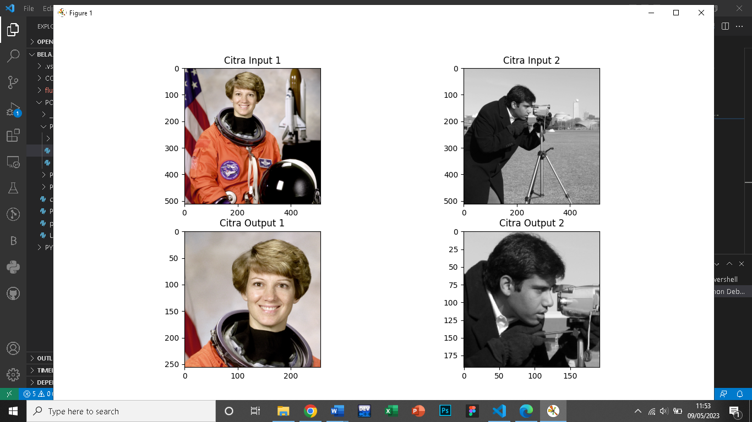

1. Inverted image

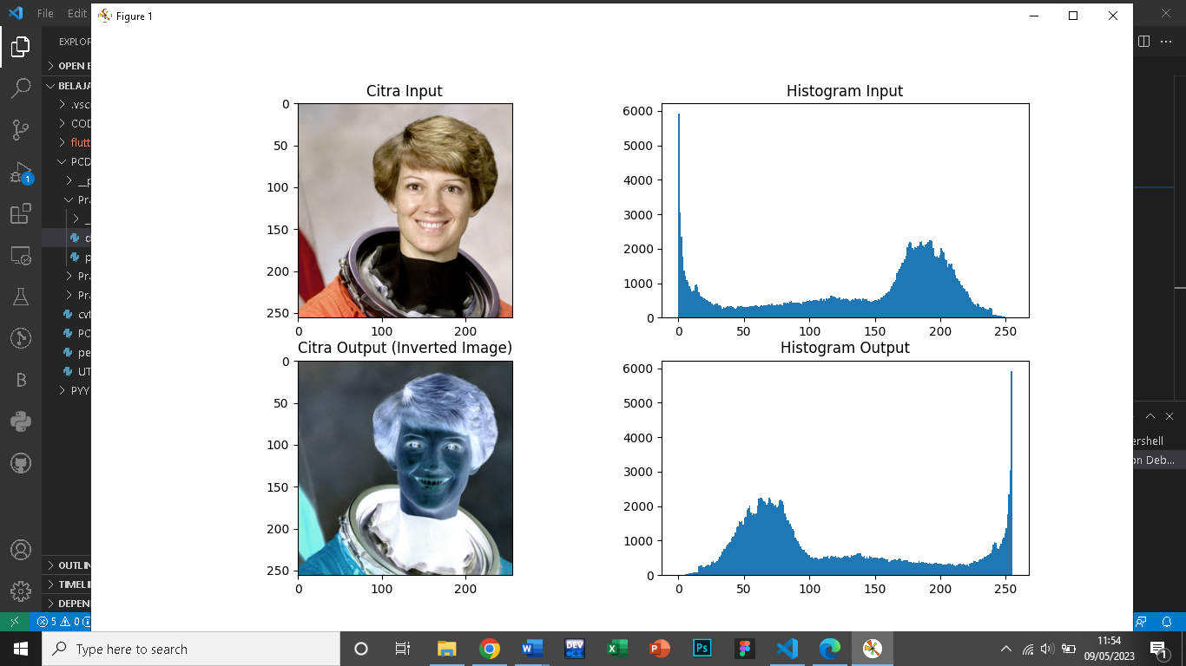

1. Brightness grayscale 1

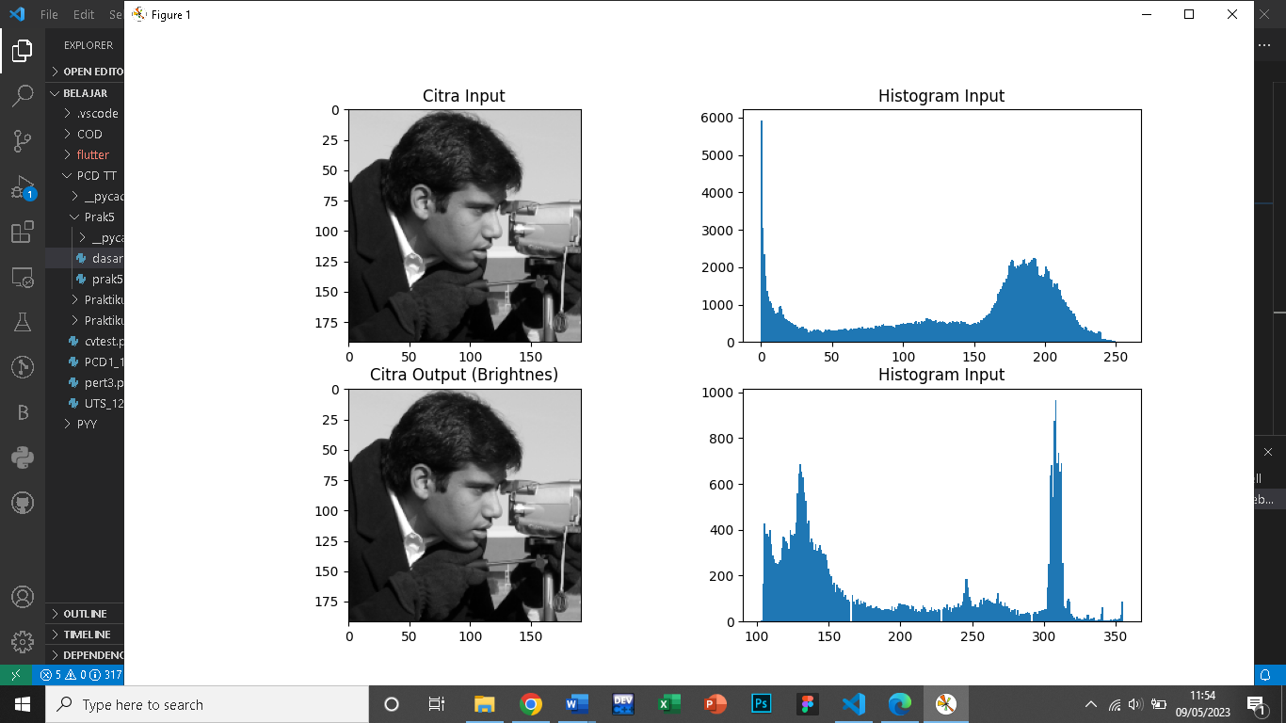

1. Brigntess and RGB Brightness

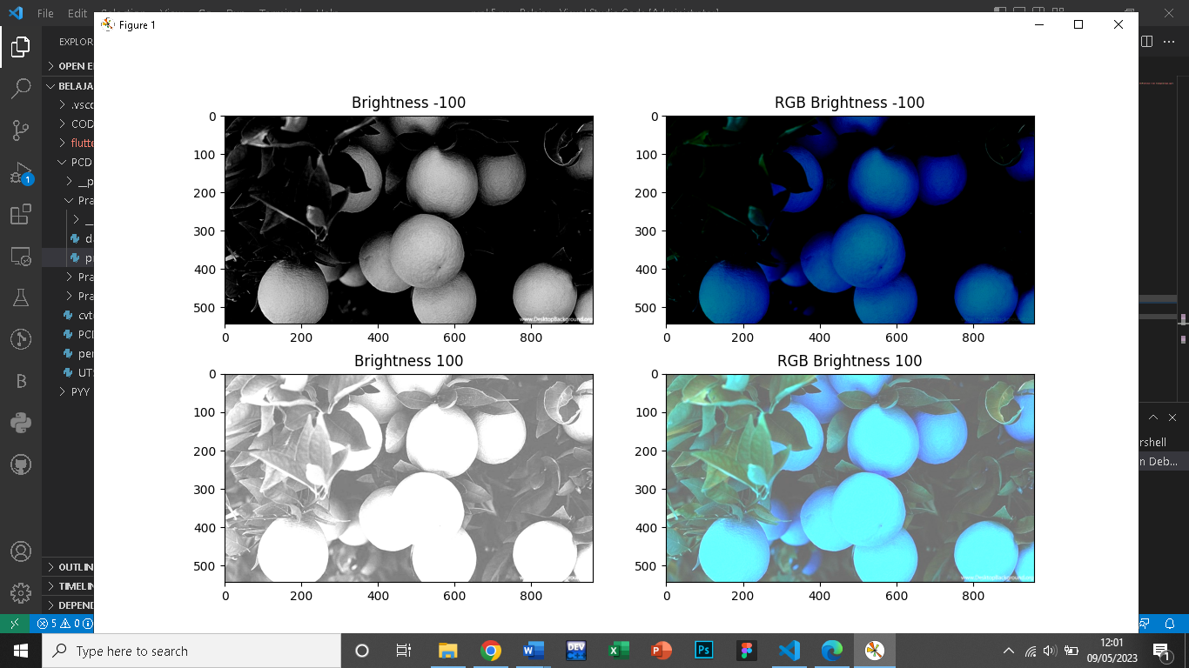

1. Contrass and RGB Contrass

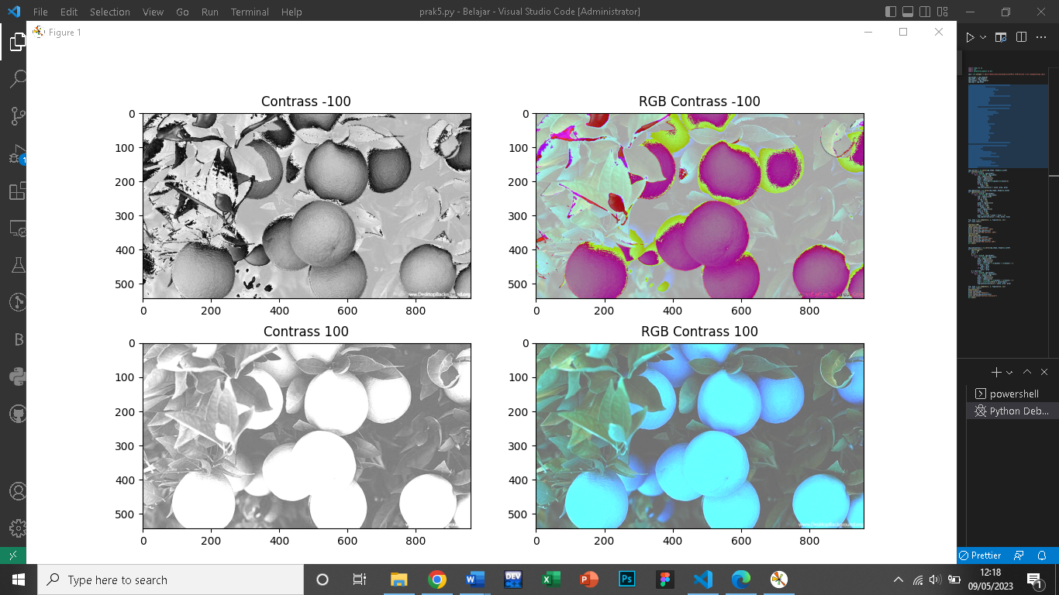

1. Contrass Autolevel

